% modeling Motor
% Pittman 14204S006 Lo-Cog DC servo Motor
% Encoder resulation 500 CPR
Kt=6.12E-02 % N-M
Ke=6.12E-02 % V/rad/s
Ra=1.01 % ohm
L=1.6e-3 % H
Jm= 2.6E-5 % kg-m^2
Tf=1.6 % N-m friction torque
b=1.2e-5 % friction , Viscous damping N-M/s

% From text book p.55 eq(2.71)
% we get
K= Kt/(b*Ra+Kt*Ke)
Tau=Ra*Jm/(b*Ra+Kt*Ke)
% K =
% 16.2872
% Tau =
% 0.0070

% Rad/s ( Output)
% -------
% Voltage( Input )
num=[K/Tau]
den=[Tau/Tau 1/Tau]
% num =
% 2.3305e+003
% den =
% 1.0000 143.0906

sysG=tf(num,den)*60/(2*pi) % output is RPM
% Transfer function:
% 2.226e004
% ---------
% s + 143.1

The step response for sysG: ( motor model )
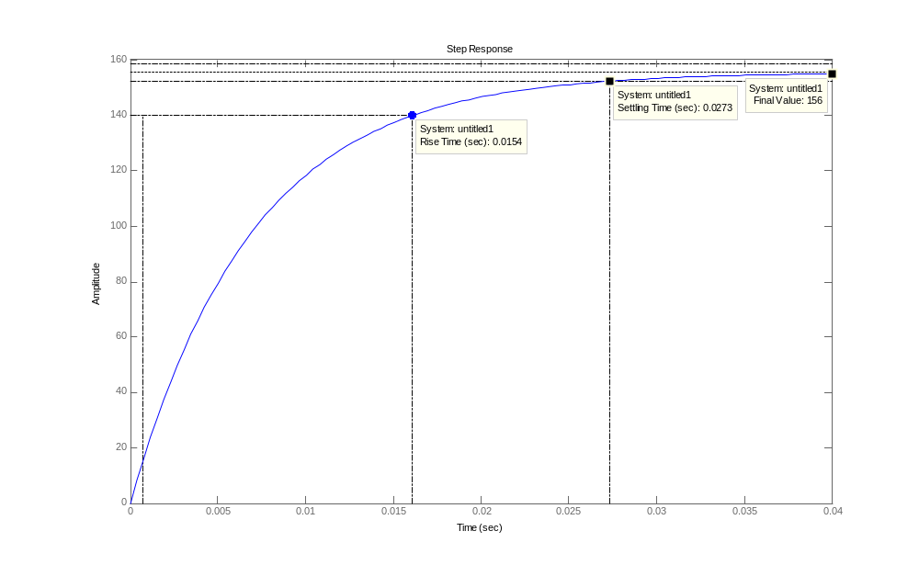
Motor step response

Design a close loop controller put the desire pole at -143.2 ( to reduce the Rise time by helf, 0.0072)
the step response is like following ( the input for the system should be 0.00643 ,the final value for sysG at open loop )

Kp=0.00643
sysKpG=feedback(sysG,Kp)
% Transfer function:
% 2.226e004
% ---------
% s + 286.2

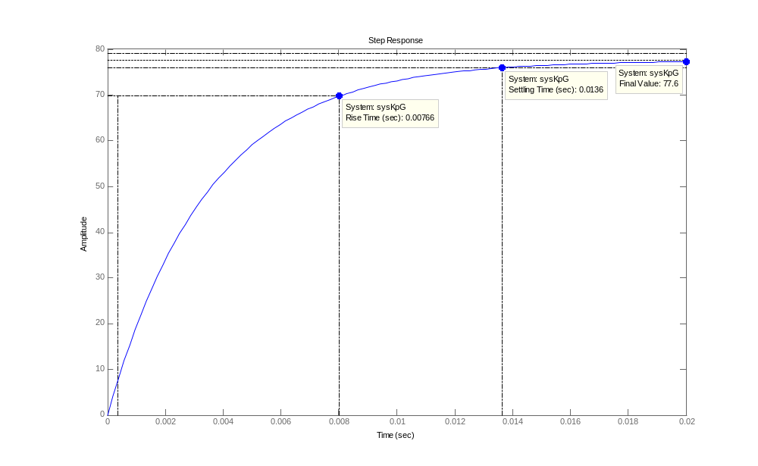
The step response after add gain Kp

From the step response, we found the steady-state error is very big, so we use sisotool again, add KI controller to help reduce the steady-state error.
The KI controller is 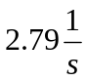
Ki =
2.79
numCI =
1
denCI =
1 0
sysKi=tf(numCI,denCI)*Ki
% Transfer function:
% 2.79
% ----
% s

sysKiKpG=feedback(sysKpG*sysKi,1)
% Transfer function:
% 6.209e004
% -------------------------
% s^2 + 286.2 s + 6.209e004
The Rise Time is 0.0072sec,Overshoot 11%,Settling Time 0.0236sec

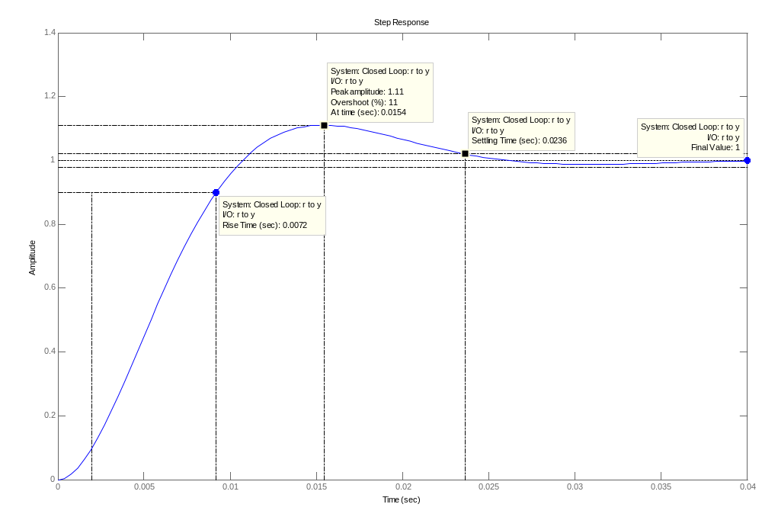
PI controller step response
we found out just add another unit feedback K=1, can get a zero steady-start erro
Kp2=1
sysKp2KpG=feedback(sysKpG,Kp2)
% Kp2 =
% 1
% Transfer function:
% 2.226e004
% -------------
% s + 2.254e004
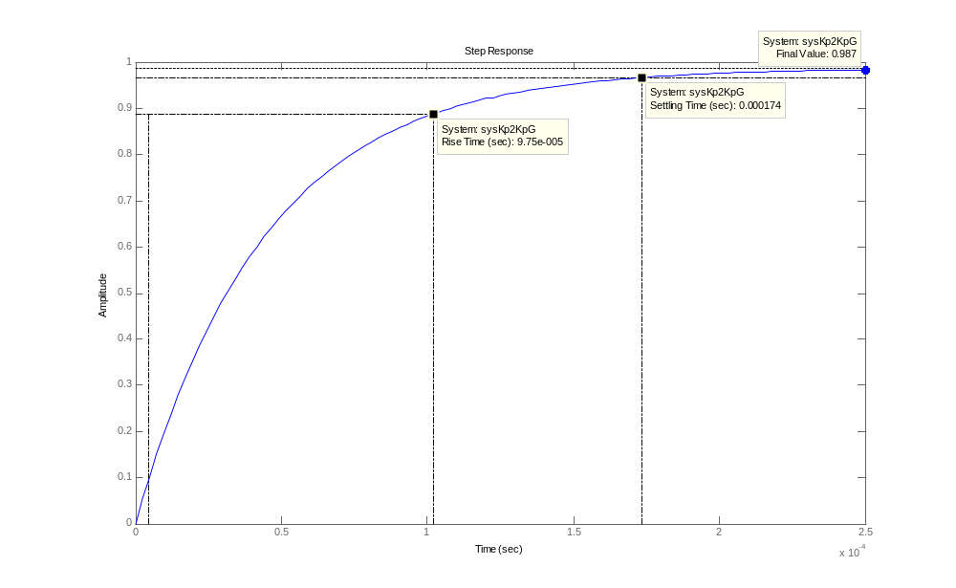

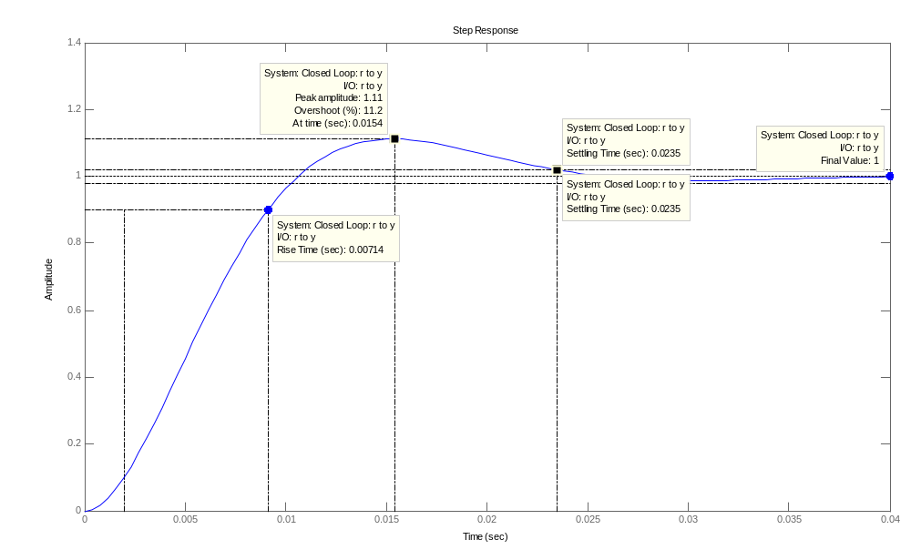
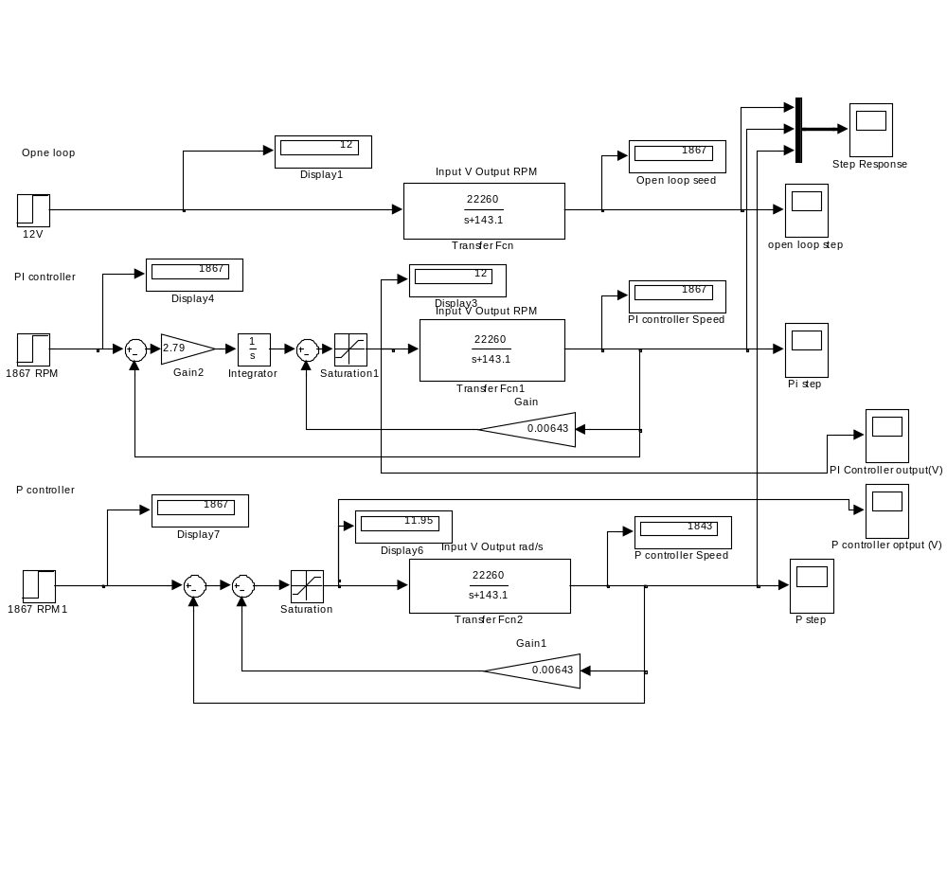
PID controller
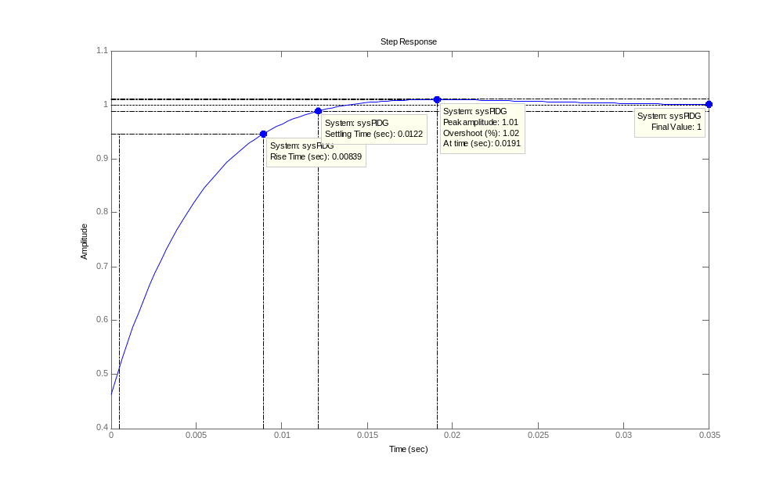
L=0.0035
R=77.6/0.005

Kp=1.2/(R*L)
Ti=2*L
Ki=Kp*1/Ti
Td=0.5*L
Kd=Kp*Td
numPID=[Kd Kp Ki]
denPID=[1 0]
sysPID=tf(numPID,denPID)
Transfer function:
3.866e-005 s^2 + 0.02209 s + 3.156
----------------------------------
s
sysPIDG=feedback(sysPID*sysG,1)
step(sysPIDG)
%% move pole to -202
% Kp =
% 0.1120
% Ki =
% 17.5124

% Transfer function:
% 0.112 s + 17.51
% ---------------
% s

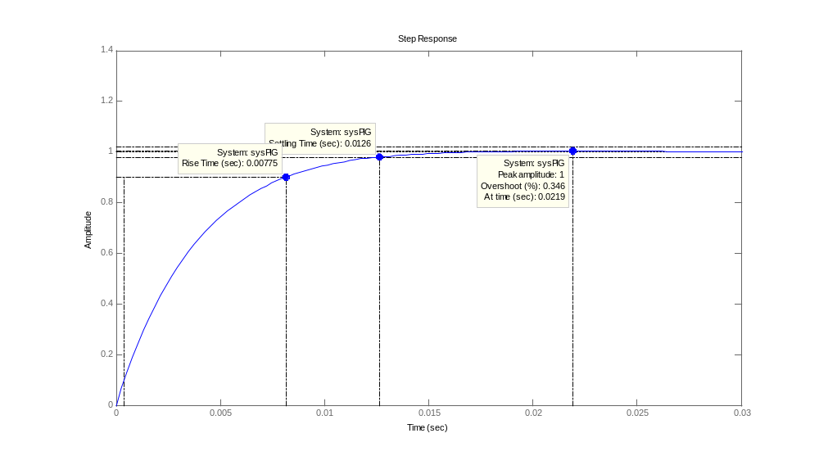
Convert the controller to z domain
Check the step response
PI controller transfer function
Zero/pole/gain:
-0.0063963 (z-1.156)
--------------------
(z-1)

Sampling time: 0.001
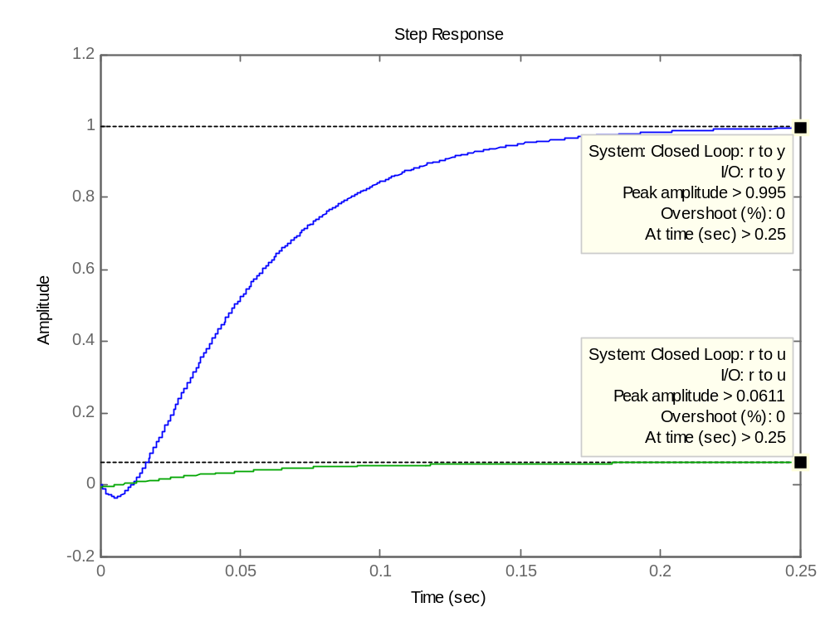
setp

